Club Cricket Review 2008-09 Season

1. Playing Numbers

 | 91/92 | 92/93 | 93/94 | 94/95 | 95/96 | 96/97 | Total | 00/01 | 01/02 | 02/03 | 03/04 | 04/05 | 05/06 | 06/07 | 07/08 | 08/09
Burnside | 17 | 16 | 18 | 20 | 21 | 20 | 112 | 19 | 17 | 20 | 19 |  |  | 23 | 22 | 24 | 144
East Shirley | 17 | 18 | 21 | 19 | 20 | 17 | 112 | 18 | 17 | 18 | 20 | 18 | 17 | 18 | 18 | 19 | 163
HSOB | 20 | 21 | 20 | 23 | 20 | 18 | 122 | 23 | 20 | 20 | 25 |  |  |  |  |  | 88
LPW | 16 | 18 | 20 | 18 | 22 | 16 | 110 | 20 | 18 | 18 | 19 | 18 | 24 | 24 | 17 | 21 | 179
Marist | 17 | 13 | 14 | 17 | 14 | 19 | 94 | 16 | 21 | 21 | 21 |  | 19 | 20 | 22 | 16 | 156
Old Coll | 19 | 18 | 18 | 20 | 20 | 18 | 113 | 18 | 18 | 21 | 25 | 28 | 26 | 28 | 30 | 30 | 224
Riccarton | 19 | 17 | 16 | 17 | 16 | 18 | 103 | 18 | 16 | 15 | 18 | 18 | 20 | 18 | 23 | 29 | 175
St Albans | 17 | 18 | 19 | 22 | 21 | 22 | 119 | 18 | 21 | 18 | 21 | 24 | 24 | 18 | 25 | 24 | 193
Sydenham | 20 | 20 | 18 | 24 | 19 | 22 | 123 | 21 | 20 | 19 | 23 | 18 |  | 24 | 20 | 23 | 168
Woolston | 18 | 13 | 14 | 14 | 15 | 17 | 91
 | 180 | 172 | 178 | 194 | 188 | 187 |  | 171 | 168 | 170 | 191 | 124 | 130 | 173 | 177 | 186
per team | 18 | 17.2 | 17.8 | 19.4 | 18.8 | 18.7 |  | 19 | 18.6 | 18.8 | 21.2 | 20.6 | 22 | 21.6 | 22.1 | 23.2

This shows an increase in the number of cricketers playing in the two day competition from an average of 18 per team in 1991-92 to 23 in 2008-09. The reduction to six senior clubs in 2004-05 and 2005-06 did not reduce the number of players per team in the competition. Also the reduction of playing days in 2008-09 did not reduce the numbers competing, in fact there was an increase of nine 177 to 186.

2. Two day competition

2.1 Scores over 200 and under 100 as percentage of innings

Two day scores over 200 under 100 as %
0.00
10.00
20.00
30.00
40.00
50.00
85/86
88/89
91/92
94/95
97/98
00/01
03/04
06/07
Over 200
Under 100
Four of the last five years have seen the number of innings score over 200 almost mirror the high scoring days of the late 1980’s. It is of interest to note that the greatest number of scores over 200 was achieved in the 2004-05 season when the competition was reduced to six teams. In 2008-09 30 scores over 200 and three over 300. The number of scores under 100 has been slowly reducing since the high of the 1999/00 season.

2.2 Results and Declarations as percentage of matches and innings

Results declarations as %
0.00
20.00
40.00
60.00
80.00
85/86
88/89
91/92
94/95
97/98
00/01
03/04
06/07
Result%
Declaration%
The number of matches that have produced an outright decision have fallen since 2001/02 and 2002/03 when around 75% of matches produced a result. In 2007-08 results and declarations had very similar figures, 42.5% and 36%, and was the closest since the mid 1980’s. There were more results and declarations in 2008-09, the figures were 54% and 44% respectively. There were 13 declarations in the last two rounds which skewed the figures greatly.

3. One day competition

3.1 Scores over 200 and under 100 as a percentage
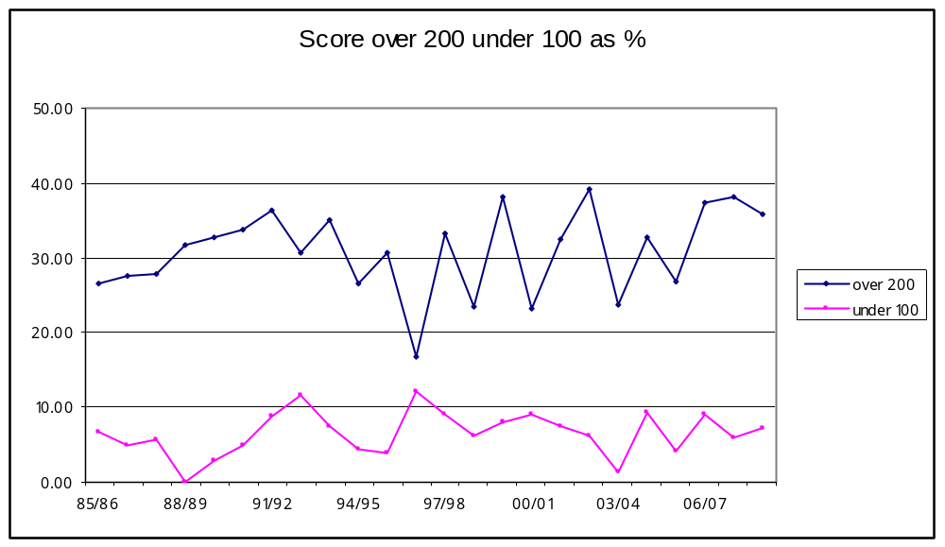
Scores over 200 follow similar trends since the 1991/92 season. There is substantial fluctuation over the past 16 years and it is somewhat disappointing that scores have not risen reflecting the trends occurring at first class and International level. However the past three seasons has seen scores remain high at around 38%. 25 scores over 200 in 2008-09 and three over 250.

4. Comparison of two and one day competitions.

4.1 Score over 200 compared
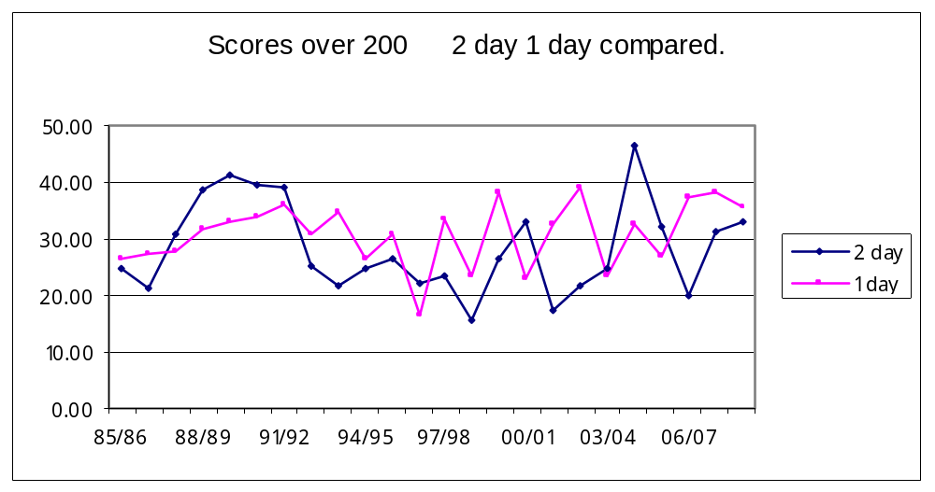
In the majority of seasons (14 out of 24) there are more team scores over 200 in the one day competition. This trend is particularly noticeable in the period from 1991/92 (12 out of 17).

4.2 Scores under 100 compared.
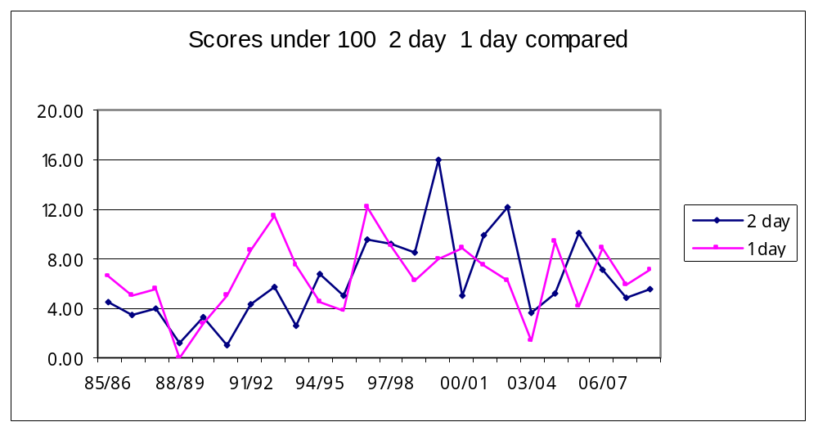
Scores under 100 were more frequent (7 out of 10) in the one day competition between 1985/86 and 1994/95. Since that time no apparent trend emerges with quite noticeable swings between the two competitions. There were five scores under 100 in both competitions in 2008-09.

5. Competition points two day cricket

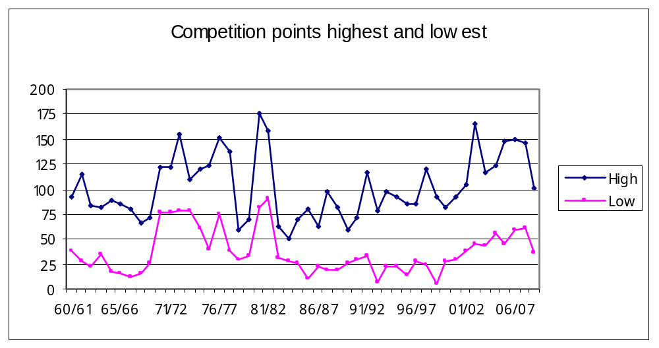

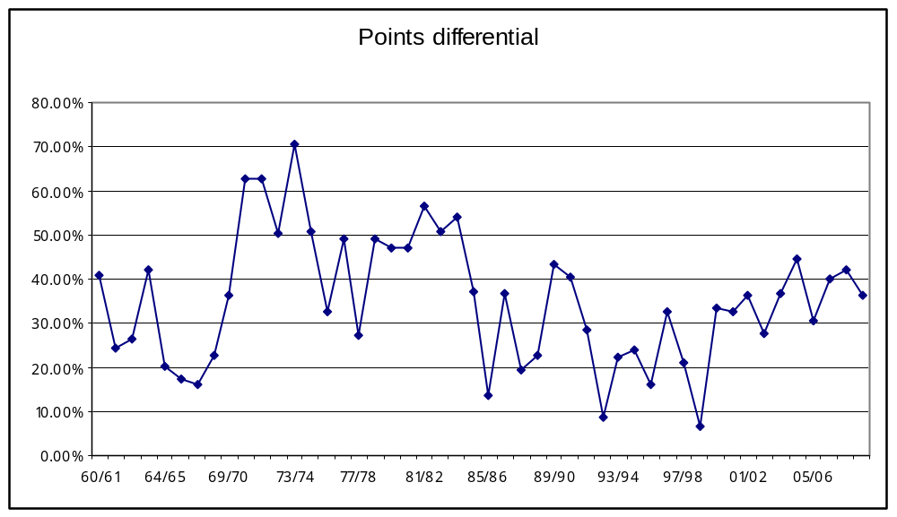
These two graphs show the points achieved by the first and last team in the two day competition since the 1960/61 season. The smallest difference occurred in the 1970/71 season (29%) and the greatest difference in the 1998/99 season when the top team had 93 points and the bottom team had 6 points. Over the past ten years the differential has remained reasonably consistent which indicates the competition has not changed markedly although it would be better if the percentage was higher.

6. Individual performances
6.1 Centuries in a season

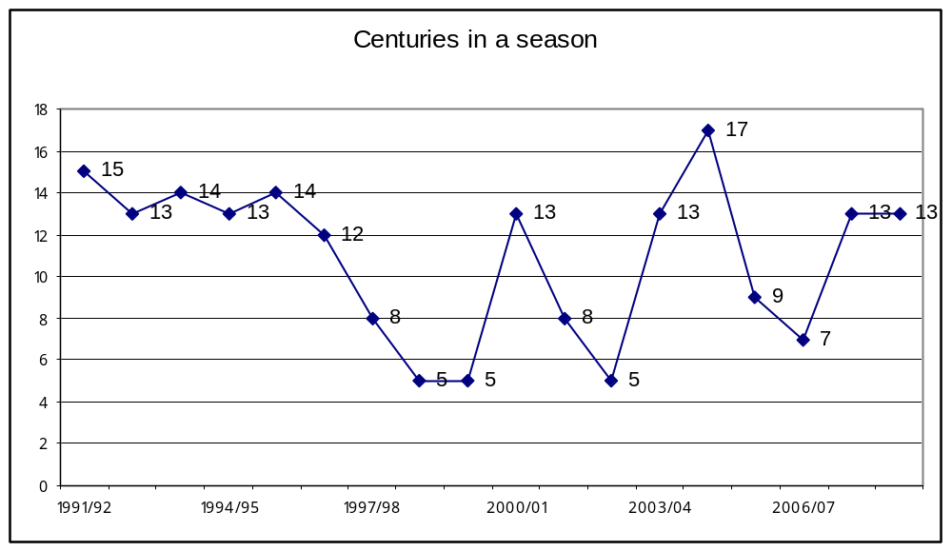
13 centuries in 2008-09, the same as recorded in the 2007-08 season, somewhat surprising with the reduced
number of matches and innings.

6.2 Batting aggregates
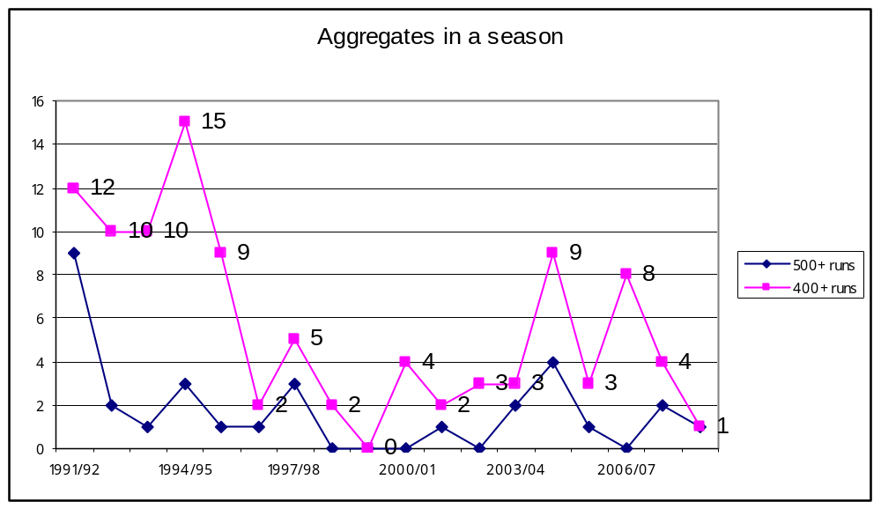
A marked reduction since 1995/96 in the number of players having high aggregates. 2008-09 produced one
aggregate over 500 and one over 400 runs.

6.3 Wickets in a season
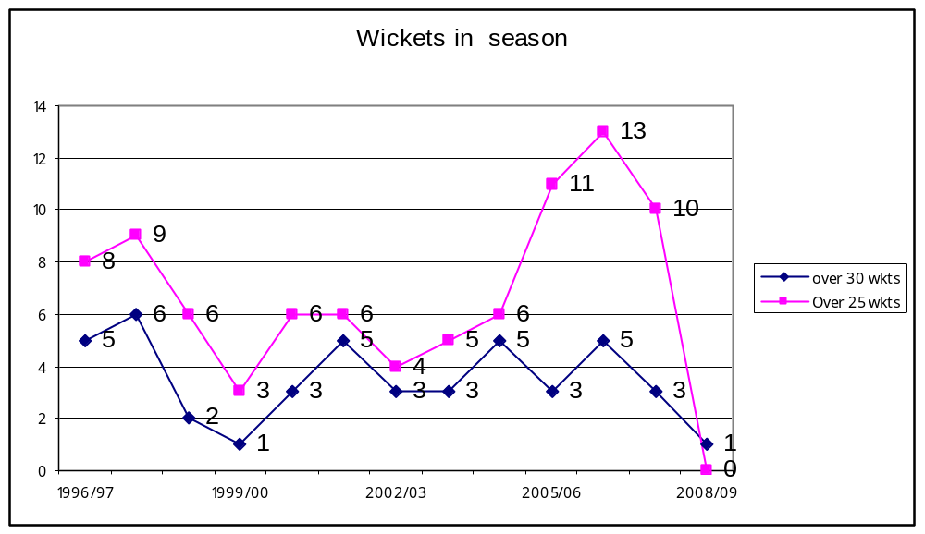
The increase in the number of bowlers taking more than 25 wickets over the previous three seasons
dropped dramatically in 2008-09 to zero. One bowler, Craig Ross took 34 wickets and the next best
was Hiini with 23 wickets.

6.4 Innings in a season
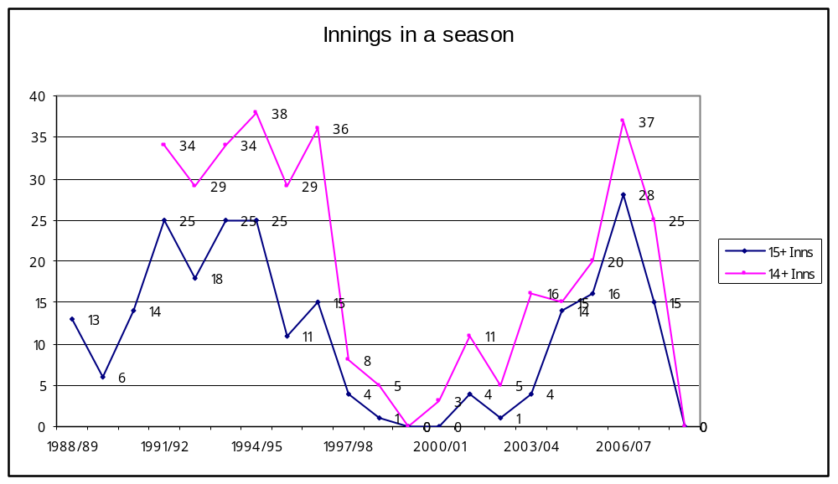
The number of individuals who had more than 14 innings has dropped to zero in 2008-09 with the
reduction in 2 day matches.

6.5 Overs bowled in a season

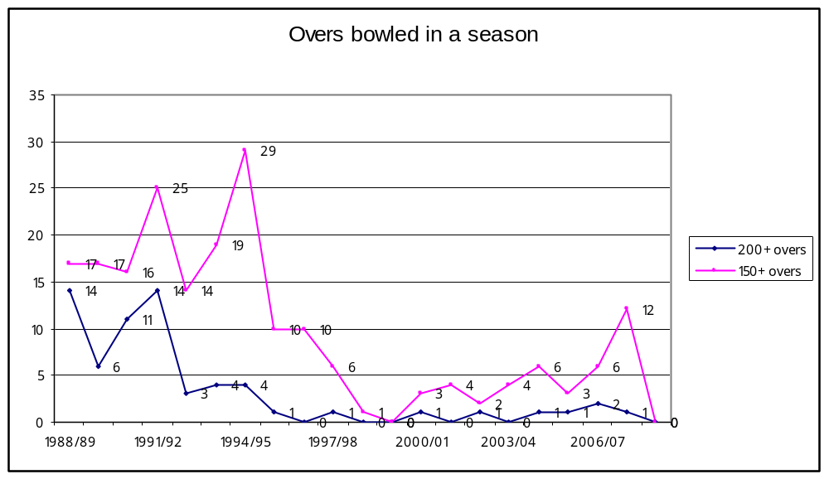
The number of individuals who bowled more than 150 overs has dropped to zero in 2008-09 with the reduction
in 2 day matches

